Unit 11 Practice Test:
1) Which situation is an example of bivariate data?
- the number of pizzas Tanya eats during her years in high school
- the number of times Ezra puts air in his bicycle tires during the summer
- the number of home runs Elias hits per game and the number of hours he practices baseball
- the number of hours Nellie studies for her mathematics tests during the first half of the school year
2) In a class, which data can be classified as qualitative?
- age of students 3. weight of students
- shoe size of students 4. hair color of students
3) A school newspaper will survey students about the quality of the school’s lunch program. Which method will create the least biased results?
- Twenty-five vegetarians are randomly surveyed.
- Twenty-five students are randomly chosen from each grade level.
- Students who dislike the school’s lunch program are chosen to complete the survey.
- A booth is set up in the cafeteria for the students to voluntarily complete the survey.
4) A school wants to add a coed soccer program. To determine student interest in the program, a survey will be taken. In order to get an unbiased sample, which group should the school survey?
- every third student entering the building
- every member of the varsity football team
- every member in Ms. Zimmer’s drama classes
- every student having a second-period French class
5) Twenty high school students took an examination and received the following scores:
60, 68, 70, 72, 73, 73, 74, 75, 78, 82, 82, 82, 85, 86, 86, 88, 88, 90, 92, 93
One more student took the exam and his score was 10, which statement about the median and mean is true?
- Both will decrease. 3. Only the median will decrease.
- Only the mean will decrease. 4. Neither will change.

Answer the following Questions. (Show all your work)
6) The heights, in feet, of former New York Knicks basketball players are listed below.
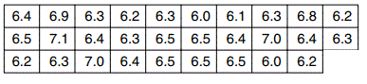
    - Using the heights given, complete the interval frequency table below.
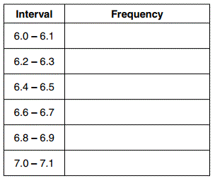
b. Based on the frequency table created, draw and label a frequency histogram on the grid below.
c. Determine and state which interval contains the upper quartile. Justify your response.

  - Noah conducted a survey on sports participation. He observed two team, a basketball team and a soccer team. The ages of the players in the basketball team are
5, 6, 7, 8, 9, 12, 12, 13, 13, 13, 13, 13, 14, 14, 14, 14, 14, 14, 14, 14
- Construct a frequency table for the data.

- Make a well labeled dot plot with a number line. (2 pts)

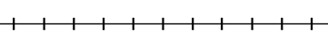

- Calculate the mean, median, range and the standard deviation of this population to the nearest hundredth of the data above?
Mean: Median: Range: Standard Deviation:
- Describe the distribution. Explain your choice.

  - The ages for the soccer players are
6, 7, 7, 8, 8, 8, 8, 9, 9, 9, 9, 9, 9, 10, 10, 10, 10, 11, 11, 12
    - List the 5 statistical data summary that will help construct a box plot.

    - Calculate the interquartile range IQR

    - Construct the box plot.

    - Describe the distribution.

- Looking at the Dot -plot in the previous question and this Box -plot which players (basketball vs soccer) have a greater mean of age? By how much?

- Which set (basketball players vs soccer) has a greater spread of data? Explain your reason.

Review Questions:
- Gretchen has $50 that she can spend at the fair. Ride tickets cost $1.25 each and game tickets cost $2 each. She wants to go on a minimum of 10 rides and play at least 12 games. Which system of inequalities represents this situation when r is the number of ride tickets purchased and g is the number of game tickets purchased?

- 1.25r + 2g < 50 3. 1.25r + 2g ≤ 50
r ≤ 10 r ≥ 10
g > 12 g ≥ 12

- 1.25r + 2g ≤ 50 4. 1.25r + 2g < 50
r ≥ 10 r ≤ 10
g > 12 g ≥ 12

2) As x increases beyond 25, which function will have the largest value?
- f(x) = 1.5^{x} 3. g(x) = 1.5x + 3
- h(x) = 1.5x² 4. k(x) = 1.5x³ + 1.5x²
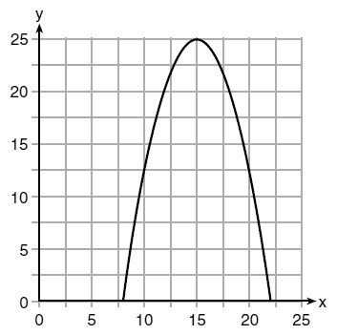
3) The graph of a quadratic function is shown below.
An equation that represents the function could be
- 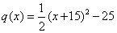
- 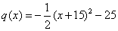
- 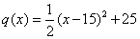
- 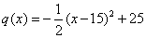
4) If f(x) = $\frac{1}{2 }$x² – ($\frac{1}{4}$x + 3), what is the value of f(8)?
- 11 3. 17
- 27 4. 33
5) If the domain of the function f(x) = 2x² – 8 is {–2, 3, 5}, then the range is
- {–16, 4, 92} 3. {–16, 10, 42}
- {0, 10, 42} 4. {0, 4, 92}
6) A plumber has a set fee for a house call and charges by the hour for repairs. The total cost of her services can be modeled by c(t) = 125t+ 95. Which statements about this function are true?
I. A house call fee costs $95.
II. The plumber charges $125 per hour.
III. The number of hours the job takes is represented by t.
- I and II, only 3. I and III, only
- II and III, only 4. I, II and III
7) The zeros of the function f(x) = x² − 5x − 6 are
- −1 and 6 3. 1 and −6
- 2 and −3 4. −2 and 3
8) The method of completing the square was used to solve the equation x² − 6x + 3 = 0. Which equation is a correct step when using this method?
- (x − 3)² = 6 3. (x − 3)² = −6
- (x − 3)² = 3 4. (x − 3)² = −3
9) A construction company uses the function f(p), where p is the number of people working on a project, to model the amount of money it spends to complete a project. A reasonable domain for this function would be
- positive integers
- positive real numbers
- both positive and negative integers
- both positive and negative real numbers
10) Which expression is equivalent to 36x² − 100?
- 4(3x − 5)(3x − 5)
- 4(3x + 5)(3x − 5)
- 2(9x − 25)(9x − 25)
- 2(9x + 25)(9x − 25)

